**PANDAS CHALLENGE REPORT**

The key insights I gained from analysing the data are as follows:-

1. The Independent schools have a better academic outcome when compared to the Government schools. Across Mathematics, Reading and Overall passing percentage, the Independent Schools had a higher score. 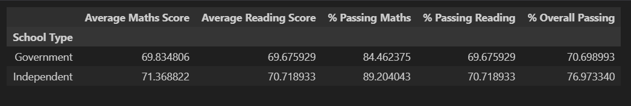
2. 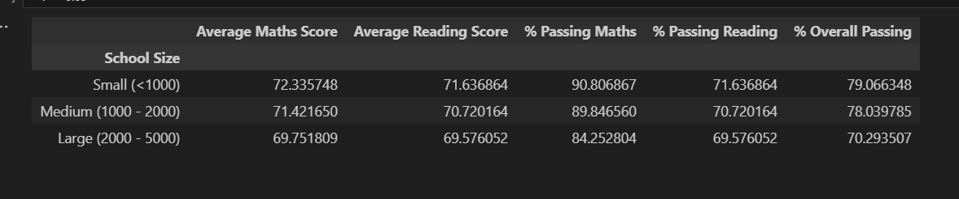The smaller the school size, the better the academic outcome of the students. This suggests that the smaller the student to teacher or administrative staff ratio, the more supervision the students have and this improves their learning outcomes.
3. The students have performed better in Mathematics with more passing the examination even though the average score is similar to that of Reading.

1. Schools with a per student spending of $585 - $630 have better academic outcome across Mathematics, reading and Overall passing. This is a dilemma that reveals that spending too much or too little can negatively affect academic outcomes in schools. The dilemma is what should be the right amount to spend per student to get the absolute best outcome.

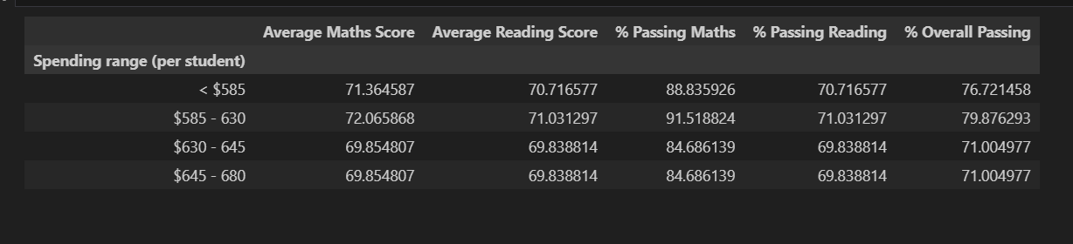

**Learning experience**

I was unable to use the pd.cut function in Pandas which would have made my analysis a bit easier.

However, I was able to get help and use DataFrame functions and filters to achieve the same outcome. If I had more time, I realised a lot of the codes I repeated and adapted could be structured into a function that could be called to split any dataset along variable bins to gain insight into the data.